Technology systems
A computer is a machine that processes digital data.
A computer installation is made up of collections of components to form a technology system.
Technology is an essential component of industry and services. Here is what technology is used for in the construction, finance, health, retail and manufacturing sector.
Manufacturing sector | Construction sector | Health sector | Retail sector | Finance sector
Manufacturing company use computed aid design systems (also know as CAD) to help them design the parts then send it them to the robotic system which uses computer aided manufacture (also know as CAM) | Construction homes, factory’s, large buildings and factories, architect’s uses computer systems to help them plan the project, crate architecture drawing, crate simulations to see if the building design will work and even track spending on projects so they don’t over spend of the goal | Doctors and pharmacies use technology to help there pactions. Good examples of this is scan patients like x-rays or MRI’s  Storing patient data  And finally a heart monitor to check the heart beating oxygen monitor to make sure the patient is breathing properly . | Retail use many different machines to get a competitive advantage on people like tracking sales using a point-of-sale system to (POS), adverts online to use e-commerce to sell product and finally product reports about sales and profit so they know what to stock up on more | Finance involves money mostly banking. The technology they use follow prices of stocks and shares; they can calculate interest rates on rates on loans and savings they can also internet banking for customers letting them check there balance through the app or website.

Issues in technology systems
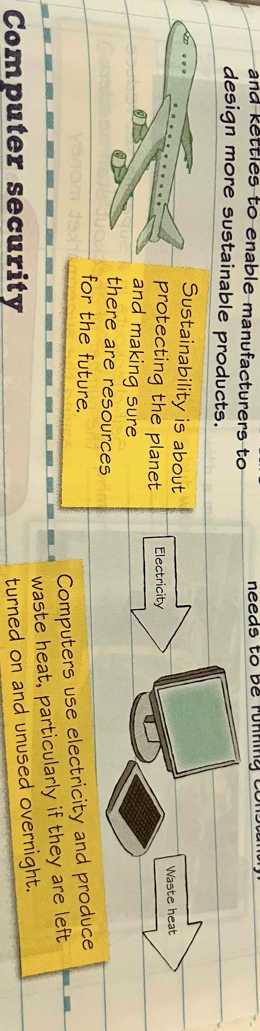
Technology systems can have both good and bad affects on the environment some examples are.
Good Environment effect | Bad Environment effect
Create sustainability. For example, video conferencing reduces the need for travel. | Bad for the planet. For example, leaving your computer on over night uses lots more electricity.
Emails can send documents electronically which reduces the use of paper and space needed to store it. | Manufacturing computers use natural resources and electricity
Digitization of things such as books and maps means that less energy is being used to produce physical product | Disposing of old computers use natural resources and electricity
Technology systems, including sensors, analyse data from products such as cars and kettles to enable manufactures to design more sustainable products | Computers produce waste heat which then needs electricity to cool, for example in server rooms the air conditioning needs to run 24/7.

Computer hardware devices
Hardware devices
You need to know about the features and use of the hardware devices shown in Table2.1.
Hardware devices are also used by technology systems for:
Inputting:
Outputting:
Storage:

What is the cpu responseible for??? Processing information and data.
Health & Safety:
The use of technology systems has rasied a number of health and safty concerns that uses of ICT sytems must be aware if to ensure they are not affected
A number of law have been passed to ensure bussnesses take the health and safety of ICT users seriously
Some of the issues include

What is better for speed??? Ssd is better then had
What dose WiFi allow devices to do???? Access the internet and a online resource.

